Digikröm

CM110/CM112

Monochromator / Spectrograph

1049517

August 2006

Introduction 3
1.1 Mission Statement 3
1.2 Warranty 3
1.3 Copyrights 3
1.4 Product Overview 3
1.5 Theory of Operation 4
Getting Started 5
2.1 Verify Shipping Contents 5
2.2 Hardware Connections 5
2.3 Baud Rate 6
2.3 Attaching a Detector 6
Operation 7
3.1 Writing Your Own Control Program 7
3.2 Hand Held Controller DK1201 (Optional) 12
3.2.1 Operation 12
3.2.2 Error Screens 17
3.2.3 Queries 18
3.2.4 Option Commands 19
3.2.5 Manual Commands 19
Appendices 20
A. Wavelength Ranges 20
B. Wavelength Scan/Slew Speeds 22
C. Encoding/Decoding Data Bytes 23
D. Status Bytes 25
E. Novram Program 26
F. Calibration 28
G. Accessories 29
H. Product Conversions 30
Changing Slits 30
Converting to a Spectrograph 30
Changing the Optical Path 30
Changing Gratings 30
I. Reference Drawings 31
Connections – Power / RS232 31
Changing the Optical Path 31
Optical Bench Mounting 32
CM110 Dimensions 33
Optical Path Design 34
J Reference CM110/CM112 Interface Pin Layout 35
K Reference Serial Relay Command 36
L..CM110/112 .Exit and Entrance flange 37

Introduction

1.1 Mission Statement
Our mission is to provide our customers with reliable products, on time, and at a fair price. We are continually striving to maintain the highest standards, by assuring defect-free products and by providing prompt and courteous customer service.
The staff at Spectral Products will be happy to answer any questions about our products and our services. For immediate assistance, please contact the Spectral Products Group directly at (505) 296-9541, by fax (505) 998-4746, or by e-mail at sales@spectralproducts.com

1.2 Warranty
This product is warranted to be free of defects in materials and workmanship for one year from date of purchase.
This manual and the software it describes are provided free of charge as a service to the customer. The software is intended to be used as a tool for development and as an example of one possible method of code implementation. It is not intended to be a “user application.”
Any software associated with this product is provided “as is” with no warranty, expressed or implied. While it is Spectral Product’s intent to provide error-free development tools, no guarantee is made regarding either the accuracy or usefulness of this material.
Failures or damages resulting from lack of operator attention to proper procedures, failure to follow operating instructions, unauthorized modifications, and natural disasters are not covered under this warranty.
The Digikröm CM110/112 does not contain any user serviceable parts. Removing its cover, without explicit written permission from Spectral Products, will void any written or implicit warranty.
Spectral Products reserves the right, without prior or further notice, to make changes to any of its products described or referred to herein to improve reliability, function, or design.
Spectral Products accepts no liability for incidental or consequential damages arising from the use of this software.
Spectral Products does not recommend the use of its components or software products in life support applications wherein a malfunction or failure of the product may directly threaten life or result in injury.
Spectral Products does not recommend that this product be used on the same power line as other equipment with high current draw requirements.

1.3 Copyrights
Spectral Products maintains the copyright on this material, but grants the customer rights to use or to modify the software described herein without obtaining Spectral Product’s permission and without the requirement to reference Spectral Products as the source of the material.
LabVIEW® is a registered trademark of National Instruments.
Windows™, Microsoft® Visual Basic™ and Microsoft® Quick Basic™ are registered trademarks of Microsoft Corporation.

1.4 Product Overview
The Digikröm CM110/112 is a one-eighth meter, Czerny-Turner type monochromator/spectrograph. Unlike other small devices that provide only one optical orientation, the Digikröm CM110/112 can accommodate both a straight through and a right-angle orientation from the source. Optical path conversion is outlined in Appendix H: Product Conversions.

1.5 Theory of Operation
The optical path of monochromators is designed so that, for monochromatic light, an image of the entrance slit is formed at the exit slit. Scanning the monochromator rotates the grating and moves this image across the exit slit. If one were to measure the intensity of the light exiting the monochromator as this scanning occurs, one would see that a triangular intensity profile results. This is shown in Fig.1 below. Diffraction and other aberrations cause deviations from this ideal situation.

Entrance image
Exit slit
No overlap
Half overlap
Full overlap
Half overlap
No overlap
I
1
1/2

λλ
Fig.1 - Formation of a spectral line

Because of the physics of diffraction gratings, entrance slit images are formed at a different angles for different
monochromatic wavelengths. Therefore, rotation the grating also selects a changing wavelength region. This is described by the grating equation...

n * λ = 2 * d * COS(∅) * SIN(∅)

This equation will be described in detail later.

Imagine a source that sends two monochromatic lines into a monchromator. If the wavelengths are sufficiently different, the two monochromatic slit images will not overlap at the exit slit. However, the finite width of the slits allows the possibility of overlap for some wavelength difference. That is, the slit width limits the ability to resolve two wavelengths.

Wider monchromator slits allow more light to enter into the instrument. Narrower slits allow for better resolution between wavelengths. This is one of the basic trade-offs in the use of monochromators.

The wavelength that is passed by the monochromator, lambda, is described by the grating equation that was presented earlier.
n * λ [nm] = 2 * d * COS(∅) * SIN(∅)

Getting Started

2.1 Verify Shipping Contents
The following items are shipped with your order of a CM110/112 1/8m monochromator:
Qty Item
1 CM110/112
1 DKFS100 Slit Set (2 each, - .125mm, .15mm, .3mm, .6mm, 1.2mm and 2.4mm slits)
1 15/5V power supply
1 Power cord
- Dual power cable
1 RS232 9 pin cable
1 User’s manual
1 CDInstalltion software. If not included, this can be downloaded from our website at www.spectralproducts.com

2.2 Hardware Connections
The CM110/112 power supply has an output patch cord with two connectors. The connector with the threaded sleeve connects to the CM110/112, while the un-sleeved connector is for the optional DK1201 hand-held controller.
- Attach the power cord to the three-prong outlet on the back of the power pack.
- Attach the connector from the power supply to the single output end of the dual output patch cord.
- Attach the locking power plug located at the other end of the dual power cable to the power jack on the back of the Digikröm CM110/112, labeled POWER. Lock it in place.
- Plug the power cord into your wall or power strip outlet. The CM110/112 will reset and find home position.

The RS232 connection requires a cable with a DB9-M subminiature connector at the monochromator, and a computer communications port connector as appropriate for the user. Spectral Products offers a DK12AT, DK12PS and DK12MA cable for connecting to AT, PS2 and MAC style computers, respectively.

Pin Assignments for the Female DB-9 Connector at Rear of CM110/112 (See Appendix J)

Pin | NAME | FUNCTION
1 | DCD | Not used with the CM110/112
2 | RxD | Data out (from CM110/112 to computer)
3 | TxD | Data in (from computer to CM110/112)
4 | DTR | Not used with the CM110/112
5 | GND | Signal ground
6 | DSR | Not used in CM110/112
7 | RTS | Request to send (from computer)
8 | CTS | Clear to send (from CM110/112)
9 | RNG | Not used in CM110/112

The pin assignments above are mapped one-to-one between the cable connection of a Digikröm CM110/112 and an IBM-AT style serial communications port.

2.3 Baud Rate
The computer must be set to the Digikröm CM110/112 data type and baud rate
Character length: 8 bits
Baud rate: 9600 bits/sec
Stop bits: 1
Parity: None
The Digikröm CM110/112 is factory configured and the character length, number of stop bits and parity cannot be changed. Its signal levels and format are the same as those that are specified for the RS-232. The CM110/112 emulates data communications equipment (DCE).

2.3 Attaching a Detector

Attach a detector to the monochromator using the bayonet mounting flange (See Appendix L). In order to maintain a tight optical seal between the monochromator and the detector, it may be useful to allow the detector’s mounting flange to protrude slightly into the hole in the slit plate. A rubber or foam gasket between flat surfaces is also frequently used.
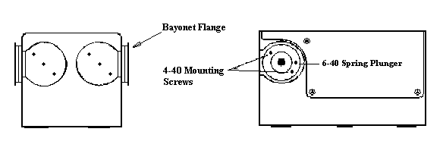
2.4 Product Specifications

- Wavelength Drive: Anti-backlash worm and wheel with microprocessor control. Bi-directional. Usable in positive or negative grating orders.
- Beam Path: Either right angle or straight through(standard configuration) from source
- Design: Czerny-Turner, dual-grating turret
- Focal Length: 110 mm
- F/#: 3.9
- Gratings: 30 x 30 mm. See the Standard Grating Table in Appendix B.
- Wavelength Precision: >0.2 nm with 1200 g/mm grating
- Wavelength Accuracy: + 0.2 nm with 1200 g/mm grating
- Slewing Speed: >100 nm/second with 1200 g/mm grating
- Maximum Resolution: 0.2 nm with 1200 g/mm grating
- Band pass: 1 nm with .150mm slit and 1200 g/mm grating
- Standard Slits (mm): 0.125, 0.15, 0.3, 0.6, 1.2, and 2.4. For other values, consult Spectral Products.
- Software: Demo control program with source is included. A LabVIEW® Driver is available upon request.
- Power: UL listed 110/220 V power pack, meets or exceeds UL1950, CSA 1402C, and IEC 950.
- Interface: RS-232 standard
- Warranty: One year from delivery date
- CE marked
- Options: Hand-held control module for local control, IEEE-488 interface, Interface cables, GPIB to RS232 converter, Gold optics for IR range.

Operation

3.1 Writing Your Own Control Program
The subscript _{D} indicates the decimal value of the byte is listed.

CALIBRATE
This command allows recalibration of the monochromator positioning scale factor and should ALWAYS be used immediately after using the ZERO command (see page 13). The monochromator should be set to the peak of a known spectral line, then the position of that line is input using the CALIBRATE command.
CAUTION: Use of this command will erase factory settings.

To CM110/112: <18>_{D} <High Byte> <Low Byte>
CM110/112 Action: If ( 256 * <High Byte> ) + <Low Byte> is a valid position, then the scale factor used in determining position will be recalibrated to make the current position agree with the input position. The gratings return to zero after completion.
From CM110/112: <Status Byte>
From CM110/112: <24> _{D}

DEC
This command decrements the zero offset value and changes the grating angle by 0.0075 degrees in the clockwise direction. This is generally always followed by the ZERO command. The CM110/112 does not track the change in wavelength incurred by this command. The new offset is not in effect unless the ZERO command is issued.

To CM110/112: <1> _{D}
From CM110/112: <Status Byte>
CM110/112 Action: Moves one motor step clockwise
From CM110/112: <24> _{D}

DEC Machine #2 (CM112 only)
This command decrements the zero offset value for machine #2 and changes the grating angle by 0.0075 degrees in the clockwise direction. This is generally always followed by the ZERO command. The CM110/112 does not track the change in wavelength incurred by this command. The new offset is not in effect unless the ZERO command is issued.

To CM110/112: <2> _{D}
From CM110/112: <Status Byte>
CM110/112 Action: Moves one motor step clockwise
From CM110/112: <24> _{D}

ECHO

The ECHO command is used to verify communications with the CM110/112.

To CM110/112: <27> _{D}
From CM110/112: <27> _{D}
CM110/112 Action: No action.

GOTO
This command moves the monochromator to a selected position. Valid values of position are grating dependent and are described in Appendix C.

To CM110/112: <16> _{D} <High Byte> <Low Byte>
From CM110/112: <Status Byte>
CM110/112 Action: If valid, move to position ( 256 * <High Byte> ) + <Low Byte> [units].
From CM110/112: <24> _{D}

For example, the command to instruct the monochromator to GOTO the wavelength 250 nm could be sent as the three bytes <16> _{D} <0> _{D} <250> _{D} (if the current units are in nm). Here, <16> _{D} specifies the8GOTO command while <0> _{D} <250> _{D} specifies the destination of 250 nm.

INC
This command increments the zero offset value and changes the grating angle by 0.0075 degrees in the counter-clockwise direction. This is generally always followed by the ZERO command. The CM110/112 does not track the change in wavelength incurred by this command. The new offset is not in effect unless the ZERO command is issued.

To CM110/112: <7> _{D}
From CM110/112: <Status Byte>
CM110/112 Action: Moves one motor step counter-clockwise
From CM110/112: <24> _{D}

INC Machine #2 (CM112 only)
This command increments the zero offset value for Machine #2 and changes the grating angle by 0.0075 degrees in the counter-clockwise direction. This is generally always followed by the ZERO command. The CM110/112 does not track the change in wavelength incurred by this command. The new offset is not in effect unless the ZERO command is issued.

To CM110/112: <8> _{D}
From CM110/112: <Status Byte>
CM110/112 Action: Moves one motor step counter-clockwise
From CM110/112: <24> _{D}

ORDER

This command determines if the grating rotates clockwise or counter-clockwise.

To CM110/112: <51> _{D} <Order Byte>
From CM110/112: <Status Byte>
CM110/112 Action: If valid, moves to the zero order position of the selected grating. Rotation of the grating thereafter will be clockwise if the order byte was 01, and counter-clockwise if the order byte was 254.
From CM110/112: <24> _{D}

QUERY

This command displays the monochromators status.

To CM110/112: <56> _{D} <Query Byte>
From CM110/112: <Status Message>

<Query Byte> Status Message
<00> _{D} <Position High Byte> <Low Byte>
<01> _{D} <0> <Type Byte>
0 = Single
1 = Additive dbl(CM112 only)
254 = Subtractive dbl(CM112 only)
<02> _{D} <Grooves/mm High Byte> <Low Byte>
<03> _{D} <Blaze High Byte> <Low Byte>
<04> _{D} <0> <Current Grating No.>
<05> _{D} <Speed High Byte> <Low Byte>
<06> _{D} <0> <Size Byte>
<13> _{D} <0> <Number of gratings>

<14> _{D} <0> <Current Units>
<19> _{D} <Serial Number High Byte> <Serial Number Low Byte>

CM110/112 Action: No action.
From CM110/112: <Status Byte>
From CM110/112: <24> _{D}

RESET

This command returns the grating to home position.

To CM110/112: <255> _{D} <255><255>
CM110/112 Action: Grating will return to home position

SCAN
This command scans the monochromator between a START position and an END position at a rate determined by the Spectral ProductsEED command. The START may be greater or smaller than the END. Valid values of position are grating and units dependent and are described in Appendix B, page 21.

To CM110/112: <12> _{D}
<Start High Byte> <Start Low Byte>
<End High Byte> <End Low Byte>
From CM110/112: <Status Byte>
CM110/112 Action: Sets CTS low, and moves below (above) the starting value. Sets CTS high and accelerates to scanning speed. Sets CTS low when the Start is reached. Sets CTS high again as END is passed.
From CM110/112: <24> _{D}

SELECT

Selects the grating that will be used.

To CM110/112: <26> _{D} <Grating Byte>
From CM110/112: <Status Byte>
CM110/112 Action: If valid, moves to the zero order position of the selected grating. Valid grating bytes are 1 and 2.
From CM110/112: <24> _{D}

SIZE
This command determines the change in magnitude and the direction of the monochromators position after a STEP command.

To CM110/112: <55> _{D} <Size Byte>
From CM110/112: <Status Byte>
CM110/112 Action: No immediate action. If the Size Byte is less than or equal to 127 (i.e., the most significant bit = 0), a subsequent STEP command will increase the position by that number of units. If the Size Byte is greater than 127 (most significant bit = 1), then a subsequent STEP command will decrease the position by that number of units.
From CM110/112: <24> _{D}

SPEED
Selects the speed at which the monochromator may scan. Valid values of speed are grating dependent and are given in Appendix B, page 20.

To CM110/112: <13> _{D} <High Byte> <Low Byte>
From CM110/112: <Status byte>
CM110/112 Action: No immediate action. If a valid value is selected, the SCAN command will thereafter cause the monochromator to move at approximately a speed value of (256 * <High Byte> + <Low Byte>) [Å/sec].
From CM110/112: <24> _{D}

STEP

Moves the monochromator by a preset amount defined by the SIZE command.

To CM110/112: <54> _{D}
From CM110/112: <Status byte>
CM110/112 Action: If valid, moves the monochromator so that the position is changed by the value determined by SIZE.
From CM110/112: <24> _{D}

TYPE*

Induces the CM112 only, to change between additive and subtractive mode. Consult Spectral Products before using this command!!

To CM112: <57> _{D}
From CM112: <Status byte>
CM112 Action: If <Type> is <01> , then the monochromator will subsequently operate in the additive mode. If <Type> is <254>, then the monochromator will subsequently operate in the subtractive mode. The monochromator will return to the zero order position in both cases.
From CM112: <24> _{D}

UNITS

This command allows the selection of units used in the GOTO, SCAN, SIZE, and CALIBRATE commands.

To CM110/112: <50> _{D} <Units Byte>
From CM110/112: <Status byte>
CM110/112 Action: If units byte is valid, the CM110/112 will move to the zero order position. The specified units will be used in subsequent commands. Note: Each grating may have a different type of unit specified. Ex; Grating 1 = Å, grating 2 = nm. The valid units bytes are listed below.

<Units Byte> <Spectral Units>
00 Microns
01 Nanometers
02 Angstroms
From CM110/112: <24> _{D}

ZERO
This command allows the recalibration of the position of the zero order transmission of the monochromator. Note: on a CM112, this will Zero both gratings at the same time. The monochromator should be set to the peak of the zero order transmission for each grating while wavelength = 0 using INC, then the zero command is entered.
CAUTION: Use of this command will erase factory settings.

To CM110/112: <52> _{D} <1> _{D}
CM110/112 Action: The current zero offset values of the gratings are saved as the zero order position.
From CM110/112: <Status Byte>
From CM110/112: <24> _{D}

*Note: The CM112 has separate digital drives in each cascaded monochromator and can be used in additive or subtractive mode. Additive dispersion provides better resolution. Subtractive dispersion provides better imaging and low temporal dispersion.
In additive dispersion, the two gratings rotate in the same direction. The grating of the first monochromator spreads the spectrum over an angular range. The grating of the second monochromator doubles this dispersion.
In subtractive dispersion, the two gratings rotate in opposite directions. The first monochromator is used to select a band pass. The second monochromator removes temporal and angular aberrations introduced by the first monochromator.

3.2 Hand Held Controller DK1201 (Optional)

The DK1201 Handheld Controller is an optional unit used to control the CM110/112 Monochromator when and if a PC is not available.

3.2.1 Operation

The DK1201 receives power from the CM110/112 power pack. Attach the free end of the dual power cable to the DK1201 extension cable. Attach other end of cable to power jack on back of controller. Once the DK1201 receives power, the control display will read:

Spectral, LLC.
Digikröm CM110/112

Connect the controller RS232 cable to the rear of the CM110/112. Connect the other end of the dual power cable to the power jack on the CM110/112. The CM110/112 will find home position and the control unit display will read:
Gr/mm=xxxxx Order:x
Blaze:xxxxx
Units:xxxxxxxxxx
READY… λ=xxxxx

The keyboard consists of 23 keys, 13 control keys, and 10 number keys, including a decimal point. The STOP option, SLIT ADJ and FILTER/SOURCE keys are disabled with the DK1201.

KEY
NamE Purpose

BACK Turn on/off back light of the LCD display.
LIGHT

ON/OFF Turns power on/off of DK1201.

GOTO The user can change the λ wavelength by entering a value for a new wavelength and then pressing enter. This command changes the grating angle, which in turn changes the wavelength at the exit slit.

OPTIONS This command offers 5 menu commands to adjust grating angle number, current units, current order, current type, and baud rate. See section 3.2.4, page 19.

MANUAL This command allows the user to change the rotation of the grating by one motor step. It also allows
• the user to set a new zero position for either λ equal to zero or a nonzero value.

SCAN The user can scan the intensity of light leaving the exit slit over a wavelength range defined as λ₂-λ₁.
The user can scan different ranges of wavelength by entering the values of λ₁ and λ₂ with this command, then pressing enter. The value of λ₂-λ₁ may be either positive or negative. Valid values of wavelength are both grating and unit dependent. See Appendix A, page 20.

SCAN This command selects the speed at which the CM110/112 will scan the intensity of light at the exit slit for a
SPEED given wavelength range. The user should refer to Appendix B, page 21 for a list of scan speeds that are appropriate for various gratings.

SLIT Not applicable

ADJ

FILTER Not applicable

QUERY Queries monochromater for specific settings.

RESET Resets the grating turret to the home position.

CANCEL Press the CANCEL to return to previous menu or use it back cursor.

ENTER Press the ENTER key after every command to carry out that action.

Use the GOTO command to instruct the CM110/112 to find a discrete wavelength. The values of wavelength are grating dependent. Once the key is pressed, the display reads:
ENTER=goto CNCL=quit
CURRENT λ=xxxxx

GOTO λ = _

In response to this prompt, the user may enter the desired wavelength value and press ENTER. During this part of the operation, the display reads:
ENTER=goto CNCL=quit
CURRENT λ=xxxxx

RUNNING…

Once the CM110/112 finds the specified wavelength, the GOTO operation stops and the READY screen appears.

The SCAN key allows the user to scan between a start and an end position specified by the user. The START position(λ₁) may be greater or smaller than the END position(λ₂). Valid values of position are grating and units dependent. The scanning speed for the SCAN command is a constant and is determined by the user. Once the SCAN key is pressed, the display reads:

ENTER=scan CNCL=quit
CURRENT λ=xxxxx

λ1 = _

Enter the starting wavelength and press ENTER. The display will then read:

ENTER=scan CNCL=quit
CURRENT λ=xxxxx

λ2 = _

Now, enter the ending wavelength and press ENTER. Note: once the scan is started it cannot be stopped unless power is disconnected. After the ending wavelength value is entered, the CM110/112 will go to the START position at maximum speed. The CM110/112 will begin scanning, while the display reads:
ENTER=scan CNCL=quit
CURRENT λ=xxxxx

SCANNING…

When the scan is complete, the DK1201 will display the READY screen.

The SCAN SPEED key allows the user to control the rate at which the wavelength changes. Values of speed are grating and units dependent and are given in Appendix B, page 21. Once the key is pressed, the display reads:
ENTER=new CNCL=quit CURRENT SCAN SPEED:
*********xxxxx**********
NEW SPEED:_

xxxxx= indicates the present scan speed.

Enter the SCAN SPEED using the number keys. Pressing ENTER will select the new scan speed. If the user does not wish to change the scan speed, pressing the CANCEL key will return to the READY screen.

The QUERY command offers 15 categories to inquire about. These categories are described in section 4.2.3, page 18.
QUERY=next CNCL=quit

cccccccccccccccccccccccccc
xxxxxxxxxxxxxxxxxxxxxxx

Note: ccccccccc = the query subject and xxxxxxx = the response from the monochromator.
Pressing QUERY again will cycle through the query options.
Pressing the CANCEL key will return to the READY screen.

The OPTIONS command offers 5 functions described in section 3.2.4, page 19. Cycle through these options by pressing the OPTIONS key. Each option is selected by pressing ENTER. Once selected, each option has submenus that will prompt the user for information. Press ENTER to accept the changes. Pressing the CANCEL will exit the OPTIONS mode and return to the READY screen.
OPT’N=next CNCL=quit
ENTER= ccccc

vvvvv

Section 3.2.5, page 19 describes the functions available under MANUAL. Note: once the MANUAL key is pressed, and you want to exit the program without entering a change, you must use CANCEL or power off the controller. The power off method will not move the mono and retain previous settings. Pressing the MANUAL key will display the following screen:

MANUAL =nxt CNCL=quit
ENTER=select
Calibrate Wavelength
STEP

Press the MANUAL key again will display:
MANUAL =nxt CNCL=quit
ENTER=select
Change zero offset
INC/DEC

Use the MANUAL key to cycle between menus. Press ENTER to select.

In response to ENTER under the “Calibrate Wavelength” menu, the display will read:

# - select CNCL=quit
STEP SIZE:xxxxx
λ=xxxxx 5-size
3=step+ 9=step-

CHANGING STEP SIZE
To change the step size, press “5” and ENTER. The DK1201 will display the following message:
ENTER=new CNCL=quit
**CHANGE STEP SIZE**
OLD STEP SIZE=xxxxx
NEW STEP SIZE=_

Valid values for step size are 1-127. Press ENTER to accept new step size or CANCEL to go back to submenu.

Current λ is displayed.
Pressing “9” decreases λ by one established step size.
Pressing “3” increases λ by one established step size.

Pressing the ENTER key will display the following message:
ENTER=new CNCL=quit
****CALIBRATION*****
OLD WAVELENGTH:xxxxx
NEW WAVELENGTH:_

Pressing the ENTER will accept the value and pressing CANCEL will exit without changing old value.

In response to ENTER under the “Change zero offset” menu, the display will read:

CM110 CM112
ENTER=zero CNCL=quit
********ZERO*********

1=Inc 7=Dec
ENTER=zero CNCL=quit
********ZERO*********
3=Inc MACH.2 9=Dec
1=Inc 7=Dec

CHANGING THE OFFSET

Note: this command will erase the values previously programmed into your NOVRAM’s memory.

To change the offset value, use the appropriate keys:
CM110 CM112

1 moves the grating one step below zero (ccw) 1 & 7 moves grating 1, one step above/below zero
7 moves the grating one step above zero (cw) 2 & 9 moves grating 2, one step above/below zero

Pressing ENTER displays:

CM110 CM112
ENTER=zero CNCL=quit
********ZERO*********

Accept new zero?
ENTER=zero CNCL=quit
********ZERO*********
3=Inc MACH.2 9=Dec
Accept new zero?

Pressing ENTER accepts new zero offset. CANCEL to exit menu without saving the changes.

3.2.2 Error Screens

VALUE INVALID
Whenever a value is entered that is out of range of the machine or the grating or the units are incorrect, the following screen appears:

VALUE INVALID
HIT ANY KEY TO CONT

Pressing any key will return the program to the READY screen.

COMPLETION ERROR
When there is a failure to complete a task, a value of 24 occurs, the following message appears:

<24> WAS NOT RECEIVED
HIT ANY KEY TO CONT.

The CM110/112 must be turned off and then back on to recover from this error

INVALID KEY
Whenever an invalid key is pressed the following message appears:

Invalid key……………….
HIT ANY KEY TO CONT.

3.2.3 Queries

QUERY | PURPOSE
CURRENT WAVELENGHTH | Displays the current wavelength.
CURRENT TYPE | Displays if the monochromator is in single, subtractive(CM112 only), or additive mode (CM112 only).
CURRENT GROOVES/MM | Displays the groove of the current grating.
CURRENT BLAZE | Display the blaze of the current grating.
CURRENT GRATING | Displays which grating is currently in the optical path.
SCAN SPEED | Displays the current scan speed.
CURRENT STEP SIZE | Displays the size of each motor step.
# OF GRATINGS | Displays the number of gratings in the unit.
CURRENT UNITS | Displays the current unit setting: microns, nanometers, or angstroms.
Serial number | Display the serial number of the unit.
Zero Offset M1G1 | Displays the number of motor steps, using motor 1, required for grating 1 to move to the “home” position to the zero order position.
Zero Offset M1G2 | Displays the number of motor steps, using motor 1, required for grating 2 to move to the “home” position to the zero order position.
Zero Offset M2G1 | Displays the number of motor steps, using motor 2, required for grating 1 to move to the “home” position to the zero order position (CM112 only).
Zero Offset M2G2 | Displays the number of motor steps, using motor 2, required for grating 2 to move to the “home” position to the zero order position (CM112 only).
Cal Offset M1G1 | Displays the number of motor steps required to move grating #1 from zero order to a specified “calibration” wavelength.
Cal Offset M1G2 | Displays the number of motor steps required to move grating #2 from zero order to a specified “calibration” wavelength..

3.2.4 Option Commands

OPTION COMMAND |  | PURPOSE
GRATING |  | The CM 110 has two gratings. This command alternates the use of gratings 1 and 2.
UNITS |  | This command changes the current units to microns, nanometers, and angstroms.
ORDER |  | This command changes the grating order by changing the direction that the grating rotates (clockwise, +, or counter clockwise, -).
TYPE |  | Not applicable. This option is installed for the CM112 only.
BAUDRATE |  | Not applicable. This option is not installed for changes.

3.2.5 Manual Commands

MANUAL COMMAND | PURPOSE
MANUAL=nxt CNCL=quit  ENTER=select  Calibrate Wavelength  STEP | Allows the user to calibrate to a nonzero wavelength. This command moves the motor one step CCW, when pressing STEP+, and one step CW when pressing STEP-.
MANUAL=nxt CNCL=quit  ENTER=select  Change zero offset  INC/DEC | This command allows the user to recalibrate to a zero wavelength or a nonzero wavelength.

Appendices

A. Wavelength Ranges

The CM110/112 is restricted to angles between 0 and 70 degrees. The upper restriction is imposed because the grating is almost edge-on to the incident beam beyond this angle.
From these restrictions, one may use the grating equations to calculate the valid ranges and step sizes for any particular grating. The table below lists the maximum wavelength for each grating set in the CM110/112’s software.

Upper wavelength scan limit AND MAXIMUM WAVELENGTH
INCREMENTS PER ANGULAR STEP FOR DIFFERENT GRATINGS
(Lower wavelength scan limit is zero)

Grating Upper limit
Grv/mm | nm
3600 | 500
2400 | 750
1800 | 1000
1200 | 1500
600 | 3000
300 | 6000
150 | 12000
75 | 24000

Diffraction Limit to Resolution
The grating used in a CM110/112 is a reflective surface with a series of vertical parallel grooves. Collimated light is directed toward the grating, which in turn diffracts the light into component wavelengths. A slight rotation of the grating causes a change in wavelength transmission. For a fully illuminated grating, the resolution of a grating, or ability to distinguish between two wavelengths, is given by the following equation:
Example: with 1200 gr/mm, 30mm wide @ 600nm
Δλ = 600/(1200 * 30) = .017nm if grating is full
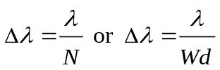
m = order
N = total number of grooves illuminated d = is groove density in gr/mm
λ = wavelength at slit W = grating width(mm)

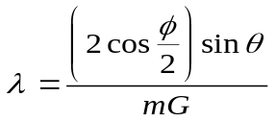

Grating Equation

Where
G – is groove density in gr/mm
φ– is the full Ebert angle. This is a fixed angle determined by the position of the grating, the collimating mirror, and the focusing mirror. It is approximately 25.4° for the CM110/112.

θ – is the angle that the grating rotates measured from the point at which white light is specularly reflected through the instrument. 70° is the maximum grating angle for the CM110/112. The CM110/112 grating drive provides a minimum Δθ of .0075°
m – is the order of diffraction. For light incident normal to the grating, some of the light will be reflected, diffracted to the right (+1 order), and diffracted to the left (-1 order). Diffraction at greater angles also occurs, but it is not significant (orders ±2, ±3, …)..

B. Wavelength Scan/Slew Speeds

Valid scan speeds required by the SPEED command are listed below:

TABLE E-1
Allowed Scan Speed Specifiers [Å/sec]

Grating
[grv/mm]
n = | 0 | 1 | 2 | 3 | 4 | 5 | 6 | 7 | 8 | 9
3600 | 333 | 166 | 83 | 41 | 20 | 10 | 5 | 2 | 1 | 0
2400 | 500 | 250 | 125 | 62 | 31 | 15 | 7 | 3 | 1 | 0
1800 | 666 | 332 | 166 | 82 | 40 | 20 | 10 | 4 | 2 | 0
1200 | 1000 | 500 | 250 | 125 | 62 | 31 | 15 | 7 | 3 | 1
600 | 2000 | 1000 | 500 | 250 | 124 | 62 | 30 | 14 | 6 | 2
300 | 4000 | 2000 | 1000 | 500 | 248 | 124 | 60 | 28 | 12 | 4
150 | 8000 | 4000 | 2000 | 1000 | 496 | 248 | 120 | 56 | 24 | 8
75 | 16000 | 8000 | 4000 | 2000 | 992 | 496 | 240 | 112 | 48 | 16

The actual scan speed of the monochromator is determined by the formula:

Actual Speed = Maximum Speed / 2^{n}

Examples:

User defines scan speed as 1000 Å/sec w/1220 g/mm grating

Actual speed = 1000 / 2 ⁰ = 1000 Å/sec

User defines scan speed as 62 Å/sec w/600 g/mm grating

Actual speed = 2000 / 2 ⁵ = 62.5 Å/sec

C. Encoding/Decoding Data Bytes

Many computer-based commands (RS-232) both send and receive information in the form of multi-byte specifiers. For a number given in decimal form, such as base 10, to be sent to the monochromator, the number must first be broken down into hexadecimal bytes (8 bits). Then, each byte is converted into a decimal value. This decimal value is transmitted as a ASCII character to the communication device. Then, the monochromator translates the characters into the form necessary to perform the operation. Conversely, the monochromator sends the data back in decimal characters. Each is a byte long, and the computer application must convert these separate bytes back to a useful decimal value.

ENCODING DATA BYTES

The desired command is GOTO 100 nm.
The GOTO command in RS-232 is specified as:

<16><HIBYTE><LOWBYTE>

where the units for the two byte specifier are determined by the current UNITS selected. For this example, the units are in Angstroms.

Step 1: Convert the desired specifier to proper units.
100 nm = 1000 Angstroms

NOTE: The following steps will be shown two ways: (A) with conversions performed by a unspecified algorithm, for example, using a calculator with decimal-hex conversion capability, and (B) using a numeric algorithm that is more suitable for computers.

Method A:

Step 2: Convert to Hexadecimal
1000(base 10) = 3E8(base 16)

Step 3: Break the hex value into two bytes
3E8(base 16) => 03 | E8
Hi Lo

Step 4: Convert each byte to its decimal equivalent
Hibyte: 03(base 16) => 03(base 10)
Lowbyte: E8(base 16) => 232(base 10)

Step 5: Send the command. The specifiers are 3 and 232.

Method B:

Note: All the following numbers are given in decimals.

Step 2: Divide by 256 and round down to the nearest whole number.
EX: 1000 / 256 = 3.90625 rounds to 3 = Hibyte

Step 3: Adjust the remainder. The remainder is the Lowbyte.
EX: 1000 - (256 x Hibyte) = 1000 - (256 x 3) = 232
Remainder = 232 = Lowbyte

Step 4: Send the command. The specifiers are 3 and 232.

DECODING DATA BYTES

The desired command is QUERY POSITION.

The QUERY POSITION command returns two bytes indicating the current wavelength, in the form

<HIBYTE><LOWBYTE>

To be useful to the user, the two bytes must be converted back to a single decimal number. As before, we can do this by either method A or method B, by essentially reversing the above procedures.

For this example, the QUERY POSITION command returns the ordered pair (5, 106), Hibyte, Lowbyte respectively, as the current wavelength. For this example, the units are in Angstroms.

Method A:
Step 1: Convert each byte to its hex equivalent
Hibyte: 05(base 10) = 5(base 16 )
Lowbyte: 106(base 10) = 6A(base 16)

Step 2: Concatenate the 2 bytes to form one hex number
05 | 6A = 056A(base 16)

Step 3: Convert the hex number to a decimal
056A(base 16) = 1386(base 10) Å = 138.6 nm.

Method B:
Note: All of the following numbers are in decimals.
Step 1: Use the formula:
Wavelength (λ) = (Hibyte x 256) + Lowbyte
(05 x 256) + 106 = 1386 Angstroms

D. Status Bytes

Whenever the CM110/112 is given a command, it will respond with a status byte that indicates whether or not the command was accepted. Each bit in the status byte has a meaning, which is given below. When a command is not accepted, some of the bits of the status byte will indicate the reason. In general, if <Status Byte>D is smaller than 128, then the command was accepted.

Bit 7: 0 if the command is accepted.
1 if the command is not accepted.

Bit 6: 0 if the command requires action
1 if the command requires no action (specifier value equals present value)

Bit 5: 0 if the specifier was too large
1 if the specifier was too small (Irrelevant if Bit 7 is 0.)

Bit 4: 0 if scan is positive going
1 if scan is negative going (Irrelevant if Bit 7 is 0.)

Bit 3: 0 if positive orders
1 if negative orders

Bit 2,1,0: Binary value is:
000 if units are microns
001 if units are nanometers
010 if units are angstroms

The SCAN command uses two specifiers. Bits 6 and 5 take slightly different meanings.

Bit 6: 1 if Lambda 1 is not acceptable
0 if Lambda 1 is acceptable

Bit 5: 1 if Lambda 2 is not acceptable
0 if Lambda 2 is acceptable

E. Novram Program

These commands are Read from Novram and Write to Novram. There are 128 memory locations in the Novram, and their addresses are from 0 to 127. Table on page 27 gives the address and the meaning in the Novram memory.

READ FROM NOVRAM

These commands read a byte from the monochromators non-volatile memory.

To CM110/112: <156>_{D}<Address Byte>
From CM110/112: <Data Byte>
From CM110/112: <Status byte>
CM110/112 Action: No action.
From CM110/112: <24> _{D}

Data Byte contains a returned value, and Address Byte is 0 through 127.

WRITE TO NOVRAM

These commands write a byte to the monochromators non-volatile memory.

WARNING !!!
Improper use of this command may corrupt the configuration and calibration information of the monochromator. Consult Spectral Products if you need to restore factory settings.

To CM110/112: <159> _{D} < Address Byte >
<Data Byte><Checksum Byte>
From CM110/112: <Status byte>
CM110/112 Action: If valid, Data Byte is saved into non-volatile memory at Address Byte.
From CM110/112: <24> _{D}

Valid choices for Address Byte are integer values between 0 and 127, and valid values for Data Byte are integer values between 0 and 255. The Checksum Byte = Address Byte + Data Byte. The checksum will be truncated to 1 byte long if its value is bigger than 255.

NOVRAM ADDRESS
Address | The meaning of the content
0 | The baudrate index: 0 is 9600 b/s
1 | Current selected grating: 1 or 2.
2 | Zero offset high byte of machine 1, grating 1.
3 | Low byte of the above number.
4 | Zero offset high byte of machine 1, grating 2.
5 | Low byte of the above number.
6 | Calibration high byte of machine 1, grating 1
7 | Low byte of the above number
8 | Calibration high byte of machine 1, grating 2
9 | Low byte of the above number
10 | Groove index of grating 1; 0: = 3600 g/mm; 1: = 2400; 2: = 1800;  3:= 1200; 4: = 600; 5: = 300; 6: = 150; 7: = 75.
11 | Groove index of grating 2. The meaning is the same as grating 1.
12 | Blazed high byte of grating 1 in nm.
13 | Low byte of the above number.
14 | Blazed high byte of grating 2 in nm.
15 | Low byte of the above number.
16 | Total gratings of machine 1.
17 | Total gratings of machine 2. (CM112 only)
18 | Zero offset high byte of machine 2, grating 1. (CM112 only)
19 | Low byte of the above number. (CM112 only)
20 | Zero offset high byte of machine 2, grating 2. (CM112 only)
21 | Low byte of the above number. (CM112 only)
22 | Order and Type. Bit 0 (for m1g1): 1 is - order, 0 is + order; Bit 1 (for m1g2): 1 is - order, 0 is + order; Bit 4 (for grating 1): 1 is subtractive dispersion, 0 is additive dispersion; Bit 5 (for grating 2): 1 is subtractive dispersion, 0 is additive dispersion. (Bits 4,5 CM112 only)
23 | Not used
24 | Current machine 1 unit – 0=centimicrons, 1=nm, 2=angstroms
25 | Current machine 2 unit – 0=centimicrons, 1=nm, 2=angstroms (CM112 only)
26 | Serial number high byte
27 | Serial number low byte
28 | Not used
29 | Not used
30 | Not used
31 | Not used
32 | AA in hex if programmed
33 | AA in hex if programmed
34 - 127 | Not used

F. Calibration
The CM110/112 monochromator uses a two-point calibration method, that is, the zero-order point and one wavelength. The zero-order point can be determined using virtually any light source, broadband or monochromatic, diffuse or coherent, since the grating is acting essentially as a mirror at this point. Using a 125 um slit, the grating position is adjusted to produce the maximum throughput. The “zero” command then stores this location into non-volatile RAM; the number stored is the number of motor steps from the device’s physical home position (determined by location sensors on the grating turret and motor shaft) to the optimized optical zero-order point.

The second point can be calibrated at almost any arbitrary wavelength, usually chosen, for convenience, to be somewhere in the middle of the particular grating’s spectral response. The monochromator compares its actual physical location with the “ideal” location for that wavelength (in terms of motor steps from zero) to produce the calibration number. This calibration number is not a count of motor steps or physical location but a scaling factor used as a multiplier throughout the range of grating motion. Therefore the monochromator takes the ideal number of motor steps (if the unit were optically and geometrically perfect) and scales it by the calibration factor. Each grating in a multiple-grating machine has its own zero and calibration numbers, compensating for mechanical or optical variations as the gratings are changed. The following are tools and procedures that can be used to calibrate the CM110/112 monochromators.

CALIBRATING ZERO WITH A HANDHELD CONTROLLER

Calibrating CM110 zero will erase the value previously programmed into your NOVRAM’s memory.
Consult Spectral Products before proceeding with CM112. CM112 Zero is factory set.
- Using a white light source, illuminate the entrance slit. Make sure the light source is aligned perpendicular to the entrance slit.
- Install your smallest slits, preferably .125 mm, at both the entrance and exit.
- Look through the exit slit. You should see the illuminated white light source.
- If necessary, you may have to reset the Zero location using the MANUAL command.
- Using GOTO, Set λ=0
- Press Enter.
- Press MANUAL. Press 4 for Inc/Dec.
- To move the motor one step counterclockwise press “1”, one step clockwise press “7”. Press either “1” or “7” until you see the white light source at its brightest intensity.
- You will be asked if you want to accept the new value for zero. You can accept or reject the changes.
- Press MANUAL to exit.

CALIBRATING AT A WAVELENGTH WITH A HANDHELD CONTROLLER

Recalibration will erase the values previously programmed in your NOVRAM’s memory.
- Using a discrete light source, such as a HeNe laser or a Hg pen lamp, illuminate the entrance slit. Make sure the light source is aligned perpendicular to the entrance slit.
- Install your smallest slits, preferably .125 mm, at both the entrance and exit.
- Use a appropriate detector for determining maximum intensity.
- Using GOTO, set λ = (to the new wavelength). Press Enter.
- If the new wavelength is not correct, enter into MANUAL mode, press 6 (step).
- At this point, you have three options: 3=STEP-, 5=SIZE, and 9=STEP+. “3“ and “9” move the motor one unit wavelength in each direction. Toggle between 3 and 9, until the light source is at its maximum intensity.
- Press MANUAL to exit.
- Press OPTIONS until CALIBRATION appears. Press ENTER.
- Enter the spectral wavelength, in the appropriate units, press ENTER to calibrate the machine.

G. Accessories

Complete listing of additional accessories and pricing is available from Spectral Products Instruments Group.

Light Sources and Calibration Lamps available through Spectral Products

Part # Description
ASB-XE-175EX Xenon fiber optic “extended” light source, with optional type S liquid light guide, 175 W in a combination power supply/lamp housing assembly. Range: 200-1100 nm.
ASB –XE-175 Xenon fiber optic “ozone blocking” light source with optional type V liquid light guide, 175 W in a combination power supply and lamp housing assembly. Range: 320-700 nm.
ASB-W-030 Visible source assembly. A 30 W tungsten-halogen lamp in housing with focusing optics. A separate constant current power supply is provided for filament temperature control. Fiber coupling is available. Range: 300-2500 nm.
ASB-D-030 UV-Deuterium source assembly. A 30 W deuterium lamp in its own housing for coupling with Digikröm monochromators. Fiber coupling is available. Range 180-400 nm.
ASC-AC Spectral calibration assembly, lamp housing and power supply for the following spectral calibration lamps.
ASC-HG Hg spectral calibration lamp. Range: 180-1020 nm
ASC-NE Ne spectral calibration lamp. Range: 800-3500 nm
ASC-XE Xe spectral calibration lamp. Range: 800-3500 nm
ASC-AR Ar spectral calibration lamp. Range: 700-1000 nm
ASC-KR Kr spectral calibration lamp. Range: 400-2200 nm
AD110B Photobyte-P Photomultiplier Amplifier System
The AD110 is a computer controlled photomultiplier amplifier, which allows current measurements while interfaced with a side-on PMT. Signals from the detector are sent via RS232, which communicates with the LabVIEW® software package. Interface cabling is provided and connections are explained in the AD110B user’s manual.
AD131 Photo detector Module
The AD130 is a Photobyte S detector module. It was designed to operate with any of Spectral Product’s monochromators. The AD131 module does not have the sensitivity of a photomultiplier tube, and is not appropriate for some applications.
Spectral Products offers a TE cooled PBS/PBSE photodiodes to extend the useable range of the AD131 module. However, due to high dark currents, this option is considerably less sensitive than alternative detection systems. Interface cabling is provided and connections are explained in the AD131 user’s manual.
Windows™ and runs on Windows™ 3.1. Interface cabling is provided and connections are explained in the AD131 user’s manual.
AF Series – A full line of fiber optic couplers, adapters, and cable assemblies that allow even greater portability of the CM110/112.

# Note: The CM110/112 entrance and exit flanges mate with all of the accessories listed above.(See Entrance and Exit Flange)

H. Product Conversions

Changing Slits
To change the entrance slit, pull the slit out from the slit mount. When sliding the slit in, you should feel the slit snap in place by the force of the ball spring plunger in the slit flange. Check and make sure that the slit is centered within the slit flange aperture.

Converting to a Spectrograph
The CM110/112 can be used in spectrograph mode when using a CCD camera. This unit has significant design differences, such as a different focusing mirror and exit port adapter (see below). Call Spectral Products for a quote on converting your CM110/112 to a CMSpectral Products110/112 or vice versa.
Motor 1
Motor 2
ENTRANCE
EXIT
ENTRANCE
EXIT

Optical Configuration of the CM110/112

Changing the Optical Path
Optical configuration may be changed to allow for either a right angle or a straight-through optical path. The Digikröm CM110/112 is factory assembled with a removable folding mirror in place, unless otherwise requested by the customer. Therefore, the instrument is usually configured for a straight-through optical path.

NOTE: only one of the two folding mirrors in the CM110/112 is removable. Before you attempt to remove the mirror, refer to page 28, and follow directions below:

The conversion of the monochromator from the straight-through optical configuration to the right angle optical configuration is a six-step process.
- The folding mirror assembly is held in place by two 4-40 screws (items #1) located at the exit flange side. Remove the two screws, and gently pull the folding mirror mount assembly out of the CM110/112 housing.
- To remove the folding mirror from its mount, remove the center 4-40 screw (item #2) that holds the mirror in place. Gently pull the mirror off of the mount. Be careful not to touch the mirror’s surface because it can be easily scratched or damaged.
- Reinsert the middle screw into the mirror mount assembly and attach with a 4-40 nut. This is necessary in order to keep stray light to a minimum.
- Move the exit flange from the side position to the position where you removed the folding mirror.
- Install the mirror mount (which you disassembled in step 2) into the opening where you removed the exit flange.
- The monochromator should be re-zeroed. NOTE: do not proceed with this step until you understand Calibrating Zero with a Handheld Controller and Calibrating at a Wavelength on pages 24 and 25.

Changing Gratings

To change gratings, please contact the Spectral Products Group at Spectral Products at (505) 296-9541.

I. Reference Drawings

Changing the Optical Path

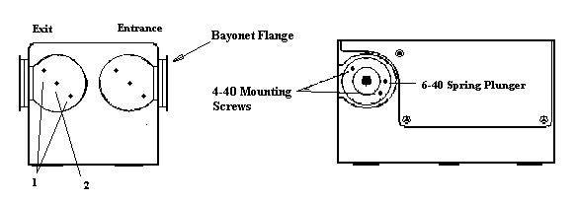

Optical Bench Mounting
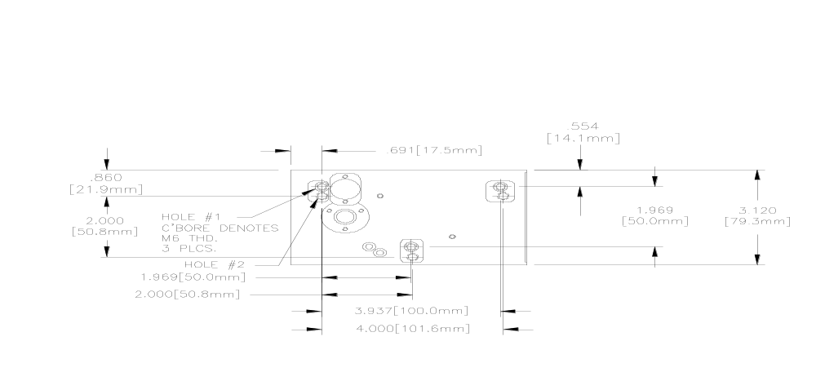

Digikröm CM110-Bottom View

Description
- M6 threads (3) used for attaching the instrument to a optical bench.
- ¼ - 20 threads (3) used for attaching the instrument to a optical bench.

Threaded holes are occupied with set screws to prevent light leaks.
If set screws are removed for mounting, retain for future use.

CM110 Dimensions

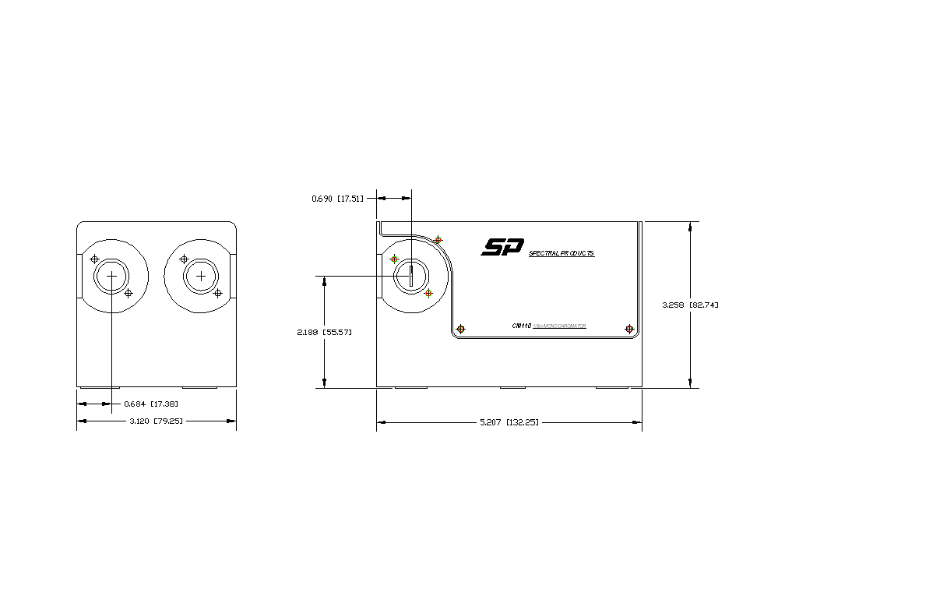

Optical Path Design
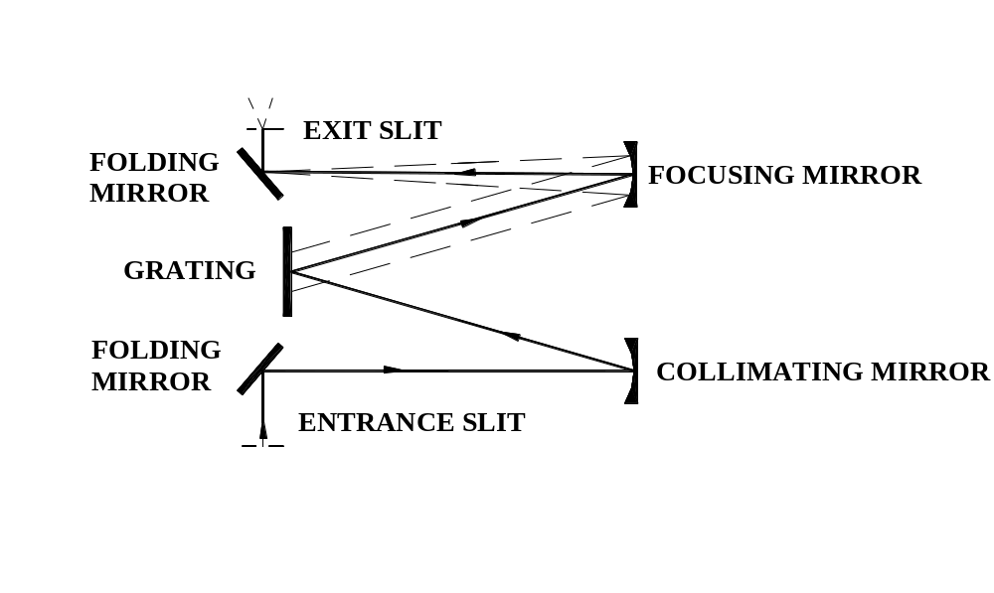

Figure 1
Schematic of the “Straight-through” Optical Configuration for the Digikröm CM110

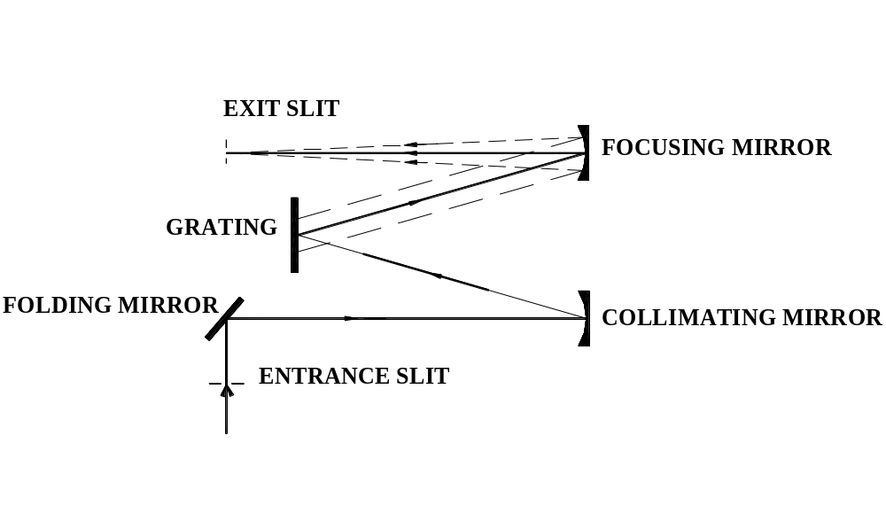

Figure 2
Schematic of the “Right Angle” Optical Configuration for the Digikröm CM110

J Reference CM110/CM112 Interface Pin Layout

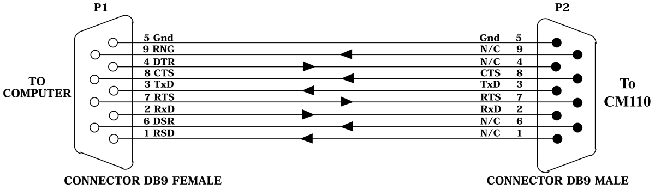
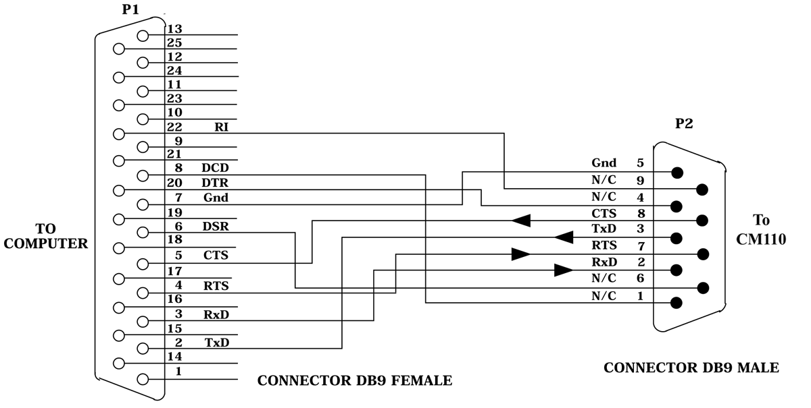
Fig. I-2 CM110 To PC 25-Pin Serial Port
Fig. I-1 CM110 to AT 9 Pin Serial Port
Connector, DB25 Female

K Reference Serial Relay Command

SERIAL RELAY OPERATION

All Spectral Products Instruments with an RS232 interfaces now support a serial relay mode. The serial mode allows multiple instruments to be controlled from one serial port.

In the serial relay mode, a daisy-chain cable allows serial messages to be relayed from instrument to instrument. Only one selected instrument will respond to the message.

A computer sends a serial message over its RxD line to instrument #1. If instrument #1 is in the SELECT state, that message is interpreted as a command. If the instrument is in the DELSELCT state, the message received on the RxD line is retransmitted on the TxD line. The handshaking signals (CTS,.RTS) are similarly relayed. The deselected instrument acts as a repeater.

DELSELECT COMMAND
The DESELECT command places the instrument in a serial relay mode. In the mode the instrument will echo all inputs. The monochromator will only recognize the SELECT command while in this mode;.

To Instrument <255> <254>
From Instrument <255> <254>
Instrument action: Relays all commands (Only recognizes select command).

SELECT COMMAND
The SELECT command places the instrument in normal operation. Because the SELECT command is serial number specific, a SELECT command will enable only a single instrument.

To Instrument <255><253> <HighByte><LowByte>
From Instrument <255><253> <HighByte><LowByte>
From Instrument <24>
Instrument action: Recognizes all commands (Normal operation).
* Where 256 * <HighByte> + <LowByte> = Serial Number of Instrument

Caution:
Only a single instrument should be selected at one time.
Therefore, a DESELECT command should precede each SELECT command.

Data Rate:
All instruments must be set for the same baud rate, number of stop bits, and number of parity bits.

L..CM110/112 .Exit and Entrance flange

